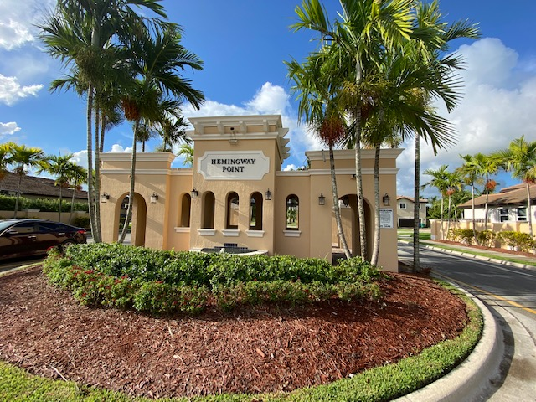

***Hemingway Point CDD***

***field report***

**March 2022**

**Governmental Management Services-South Florida, LLC**

**5385 N. Nob Hill Road Sunrise, FL 33351**

***LANDSCAPING***

* Monthly landscaping services completed by Nicoya Landscaping.

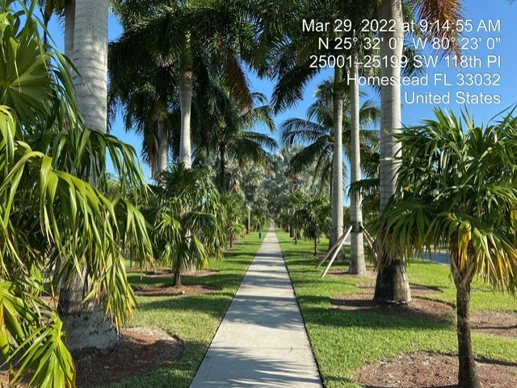

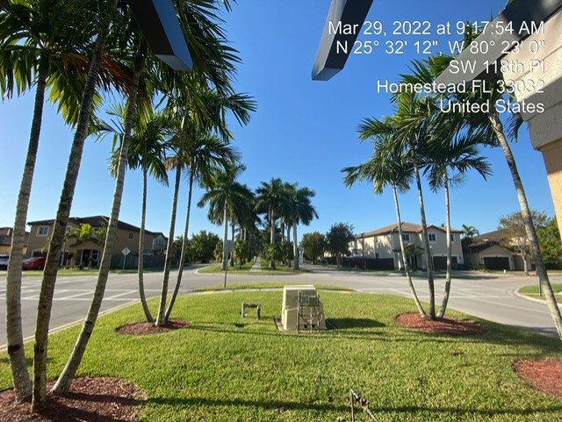

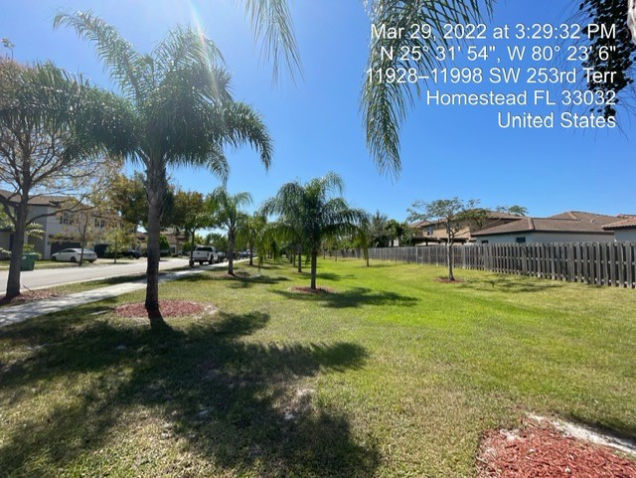

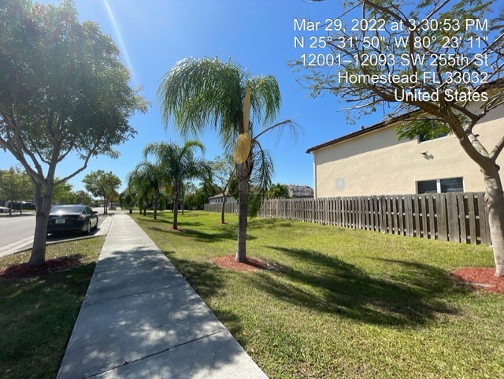

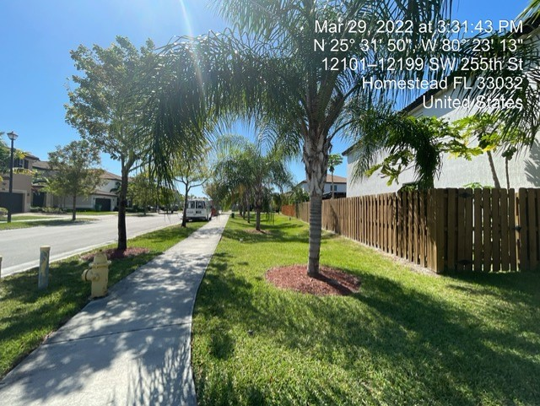

**POOL**

* Monthly pool and fountain service completed by Bright and Blue.
* Obtaining estimates to complete the cool deck painting.
* As per the Health Department inspection, working to update signage per new code requirements.

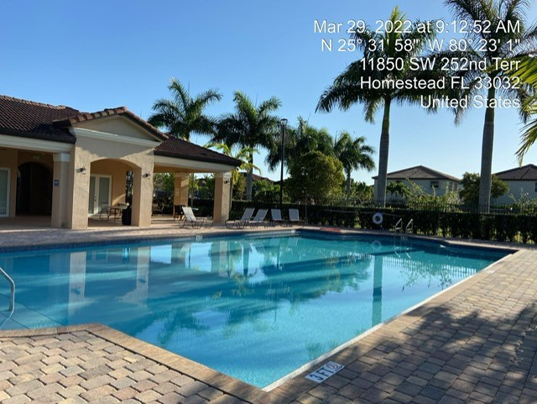

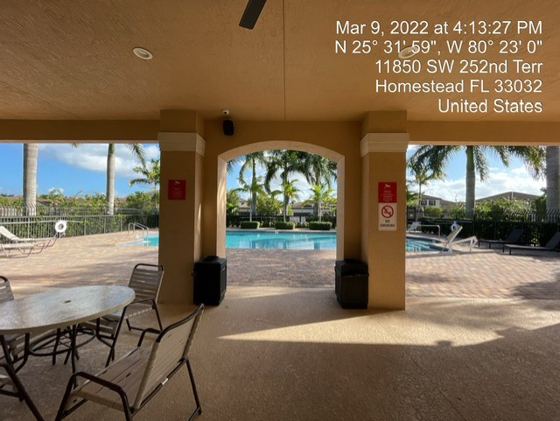

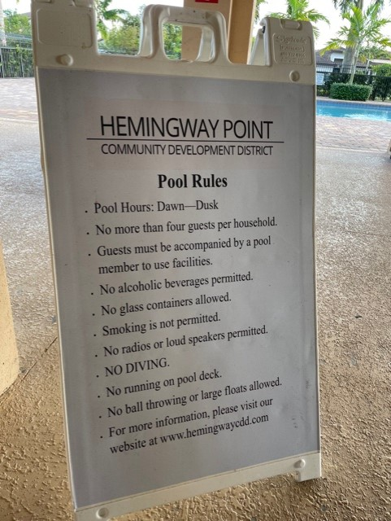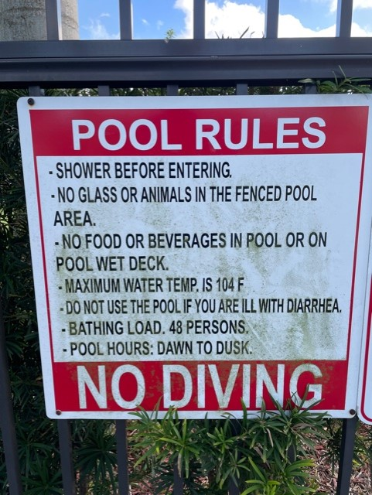

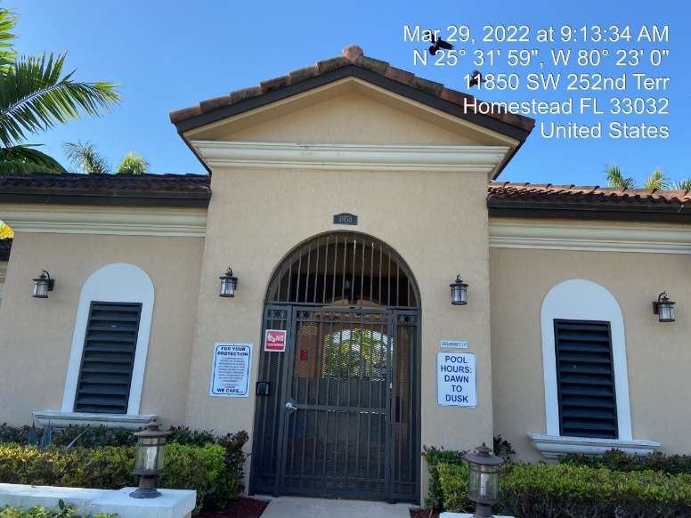

**FIELD MAINTENANCE**

* Obtaining estimates to paint the walkway and mailbox deck. Both areas have been serviced by the janitor using household cleaning products.
* Men’s bathroom toilet repaired March 30 by Ortiz Construction.
* Additional security staff obtained for Spring Break Holiday.
* Playground in satisfactory condition.
* Downed light post at the entrance of community was reported to FPL on March 8, ticket #678. FPL completed the repairs, please see before and after photos below for more details.

