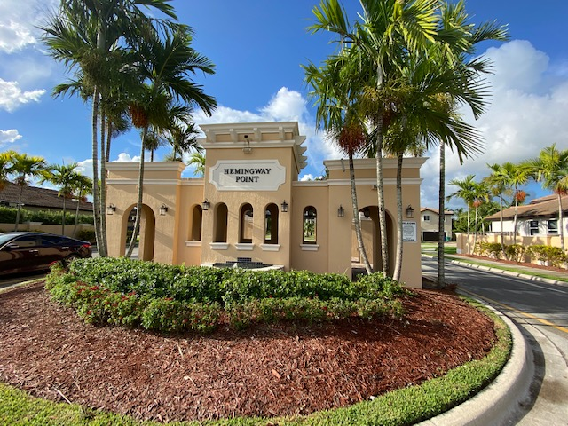

***Hemingway Point CDD***

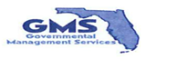***field report***

**May 2022**

**Governmental Management Services-South Florida, LLC**

**5385 N. Nob Hill Road Sunrise, FL 33351**

***LANDSCAPING***

* Monthly landscaping services completed by Nicoya Landscaping.
* All District palms were trimmed along public right of ways.
* All District palms were drenched with food/fertilizer.

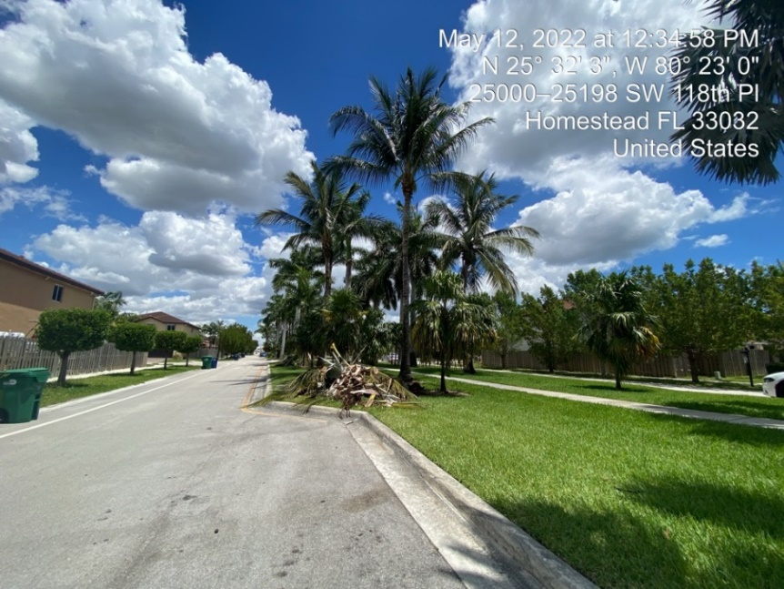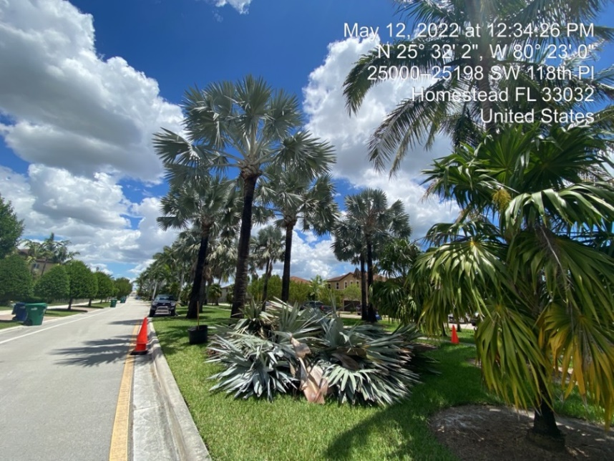

**POOL**

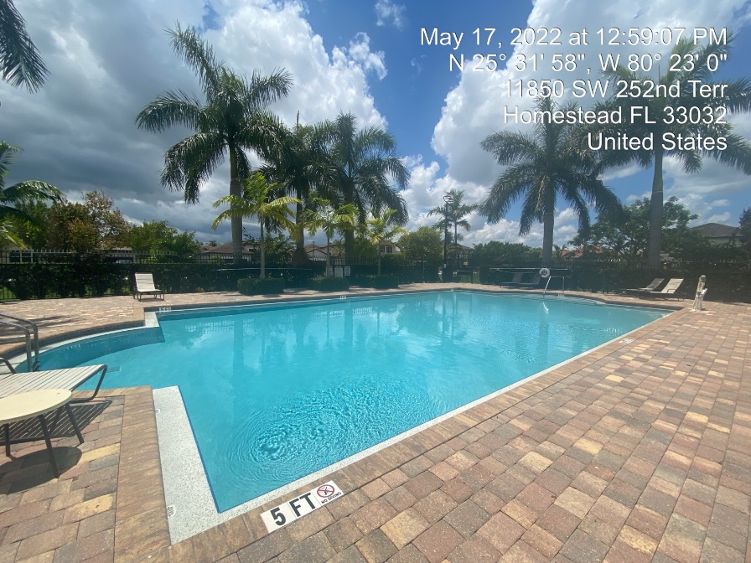

* Monthly pool and fountain service completed by Bright and Blue.
* Cool deck painting was completed.

